**Bug Report**

Summary: Missing categories from category filter section

Priority: 3

Steps:

1. Login to Shipt and switch to Target store
2. Click “Browse”
3. Click on “Show More” for categories

Actual Result: Notice some of the categories are not list which are available in Category Drop Down

Expected Result: Category list should be same

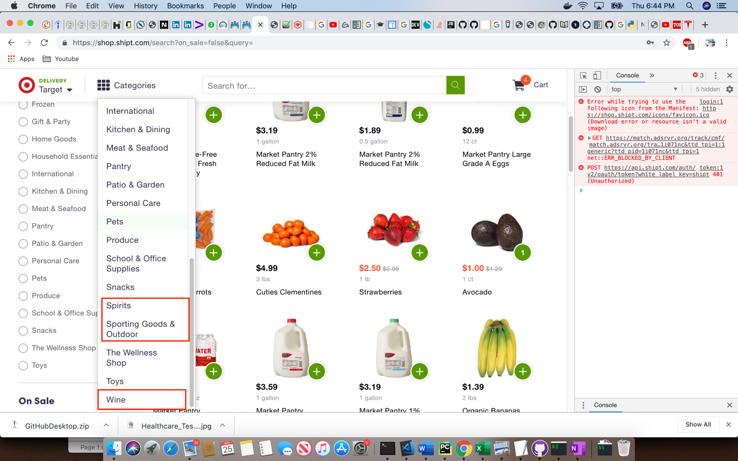

What are the possible reasons for the following defect? How would you go about debugging the problem and gathering more information?

Need to check if the source is same and verify the query from log to check why two different requests if the same table/source